# Installing a Network Printer in Windows 10

This document details the steps needed to install a printer using the Windows 10 operating system. Before installing a printer, you must make sure you are connected to the same network as the printer you want to connect to through either a network cable or a wireless connection.

1. Click on the Start button and then click Settings

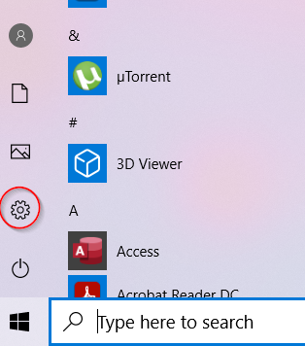

1. Click Devices



1. Click Printers & Scanners from the options on the left

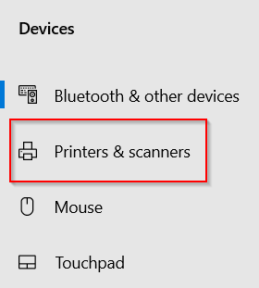

1. Click Add a printer or scanner

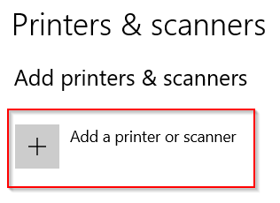

1. The system will search for available printers on your network and list any it finds

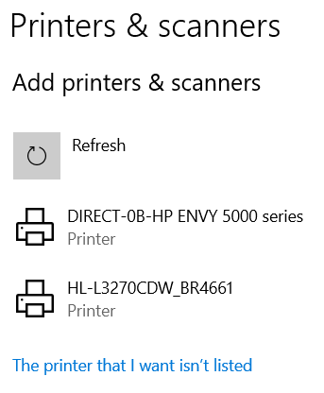

1. If you see your printer listed, click the printer name and then click Add Device

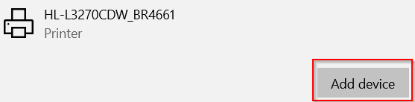

1. The printer will then be installed onto your system and will be displayed in the Printers and scanners list

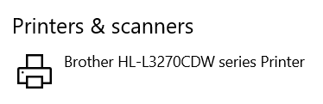

## Troubleshooting Installation Issues

**The printer you want to install isn’t found.**

Check that the printer is switched on and connected to the network. Check that your system is connected to the network.